The Earth moves around the Sun with its rotation axis tilted at 23° as shown in the diagram (not to scale).
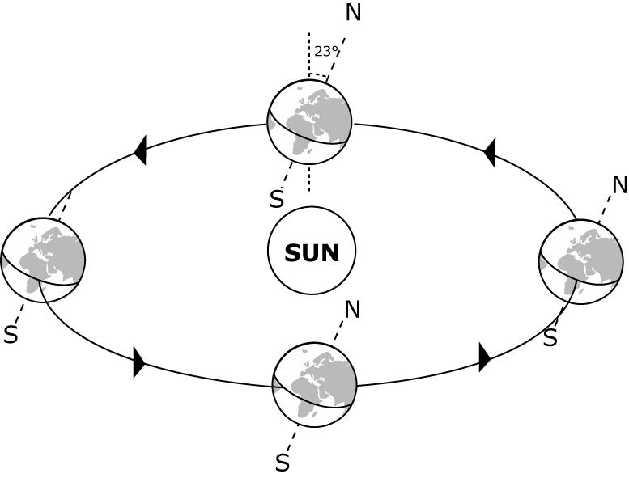
Suppose that the Earth’s axis was made to tilt at 35°, without changing anything else. What effect would this have?

The UK would get

A Longer periods of daylight in summer and shorter in winter
B Shorter periods of daylight in summer and longer in winter
C The same length of day and night that we get now

